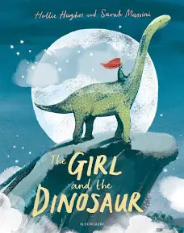
The Girl and the Dinosaur

Monday
Watch the story The Girl and the Dinosaur. Depending on the weather go outside with a parent and look at the clouds. Can you see any clouds that look like dinosaurs? Do they have spikes or longtails? Ask a family member to play a game with you and see who can spot the most. If the weather is bad you can look out of a window. Then have a go at cutting out the dinosaur shapes and create a collage.
Dinosaur video: https://www.youtube.com/watch?v=tRvM-Ohu8R0
Tuesday
Watch the video and discuss the picture PowerPoint, did you see any of the images in the video or have you see them when you went on holiday? https://www.bbc.co.uk/iplayer/episode/b094866j/our-family-series-4-6-daisy-and-lilys-beach-trip
Complete the worksheet seaside missing sounds.
Wednesday
Go through the PowerPoint, then either draw one of your favorite dinosaurs or create your own. Don’t forget to label your dinosaur once you have finished!
Thursday
Go through the PowerPoint. Then write a postcard to somebody pretending you are at the beach. Think about what you might do at the beach, what you might see, what you might hear and what you might eat?
Use your sound mat to help you spell words you are unsure as to how to spell. You can write a sentence or 3 or more words to describe your time at the beach.
Friday
Listen, learn and sing the dinosaur song.

